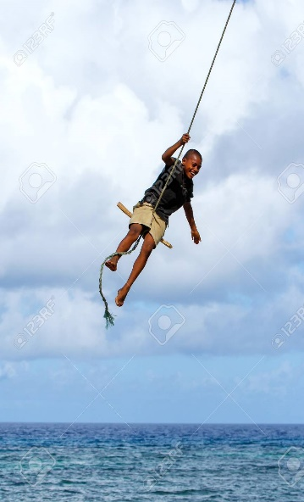
Masterpiece Thema 4 rope swinging
Intro
I am going to do my masterpiece about rope swinging. I asked my English teacher if it was already a sport. And she said she never heard of it, so it was okay. I searched on the web ‘sports’ on the web. And came across many sports. I was scrolling until I saw a rope. And I thought about all the things you can do with a rope. And then I remembered a rope swinging lesson for a PE lesson on elementary school. I did not know what ‘touwslingeren’ was in English. So, I also asked what ‘touwslingeren’ was in English to my English teacher.

Kern
There are no teams in this sport. You play this alone. The player is battling against other rope swingers. The goal is to swing as long, high, fast, and straight as possible. And punch your opponent of the rope. But than you may ask yourself how you get the power to swing as high, fast, long, and straight. Aren’t you? The answer for that is you get to stand on a big box. From five meters high. First the rope is on the other side of the field. The rope will come to you when the bell rings. we set the rope on the other side because if it is on your side, you can cheat and begin earlier. So, we do that so no one can begin earlier. your timer stops when the rope is standing completely still. There are two referees, for each player one. They will swing and throw the objects at each other. Soon after that they will swing closer to each other and punch each other until someone falls of. If the opponent falls of you will win. You will train two times a week and have a game on Saturday. The sport is also an Olympian sport.
Now I’m going to tell you about the rules of this sport.
- You need to have respect for your opponent. There are also consequences if you break this rule. If you break this rule, you cannot take part in the competition.
- You will play alone. You will ask why. You may find that strange. Don’t you? You don’t play with many players because there is no need and space for other opponents.
- You can’t jump from a higher box than 7 meters. The most used height is 5 meters. But if you really want to go high you can also choose for the 7-meter box. But your opponent also needs to want that.
- You need to use magnesium on your feet and your hands. Because you can burn your hands or feet while swinging on the rope.
- You can’t bring you own equipment. If you bring your own equipment you can cheat. In the history of this sport people cheated by bringing their own equipment.
- You may hinder your opponent by throwing balls or other objects, or punch your opponent. The objects that you throw can only be made of plastic and can’t be sharp. You can choose and use only three objects.
- In the summer and spring, the sport needs to be outside. And in the winter and fall it needs to be indoors. Because there are temperature differences the sport needs to be amended of the season.
- The light cant be to bright and not to dark. This is because you can’t perform good if you do this sport in a to bright or dark room.
- You need to have al the supplies. You need a rope, magnesium, a bit, special rope swinging clothes, head protector and a high platform.
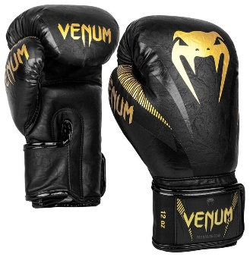
- Any age can participate in the sport. This rule is because we want to attract many people to the sport. But every age fights against age. Only training games can be held with different ages. But real competition games need to be held with the same age.
there aren’t many rules, are there?
Outro
You really need to play this sport because not many people play it. So, you can win an Olympic medal fast. You don’t have to spend time making a team because you play this alone. It is not expensive because everything you need is at the rope swinging club. The sport is also good for people that have anger issues. Because you can punch the hell out of your opponent. And al the frustration will fall right of your body on the rope. The sport can have many users. Because every age is allowed on the rope. But age fights against age so that it stays safe.
That was my masterpiece.
There are some pictures to describe the sport.

